Project Report: The Client Bridge (CRM System)
Name: Divya Rao
Project Repository: https://github.com/Divss72/The-Client-Bridge
1. Executive Summary
The Memory-Based AI CRM is an advanced Customer Relationship Management system that leverages Artificial Intelligence and Retrieval-Augmented Generation (RAG) pipelines to deeply analyze client interactions. By storing interaction data in a vector database, the CRM goes beyond traditional data tracking by providing intelligent insights, semantic search capabilities, churn prediction, and sentiment analysis. This empowers businesses to proactively manage customer relationships and make data-driven decisions.
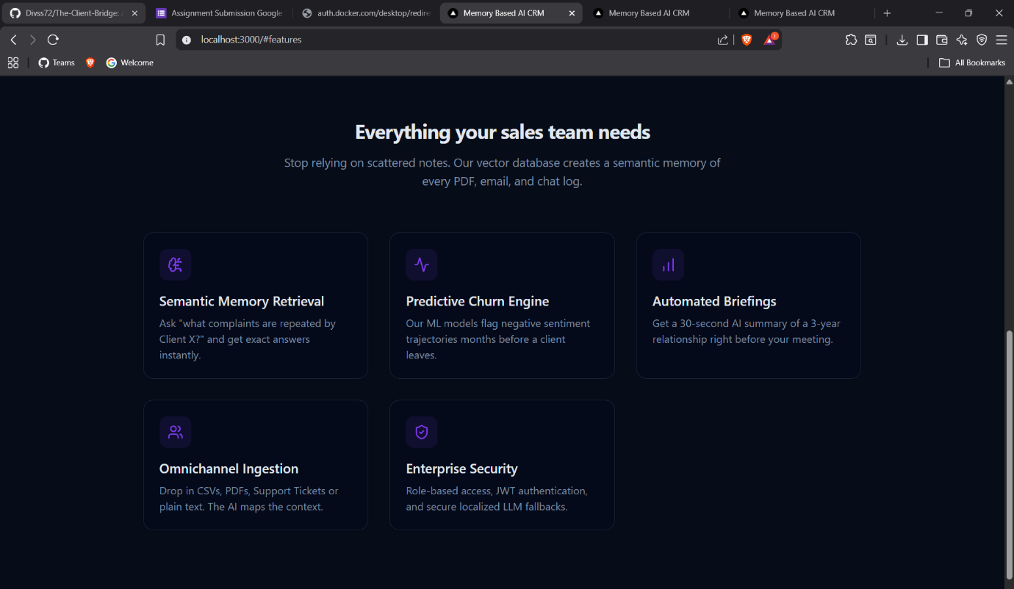
2. System Architecture
The application adopts a decoupled, modern architecture to ensure separation of concerns and scalability.
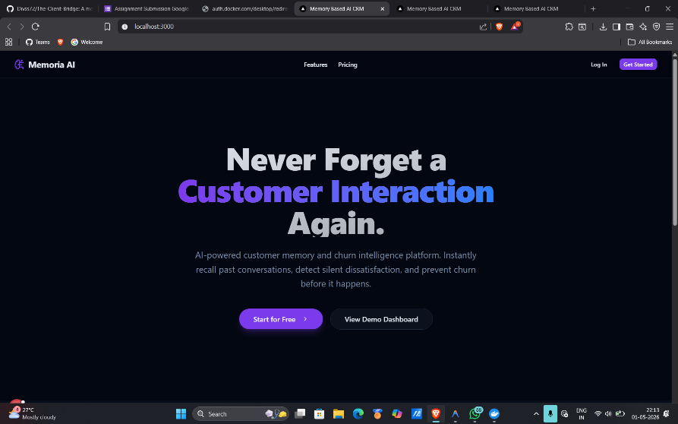
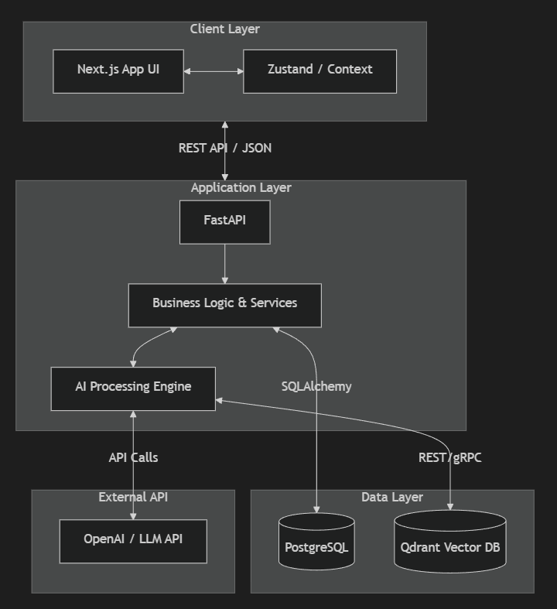

3. RAG Pipeline & Data Flow
The core value of the CRM is derived from its ability to semantically analyze interactions. Below is the workflow for how data is ingested and queried.
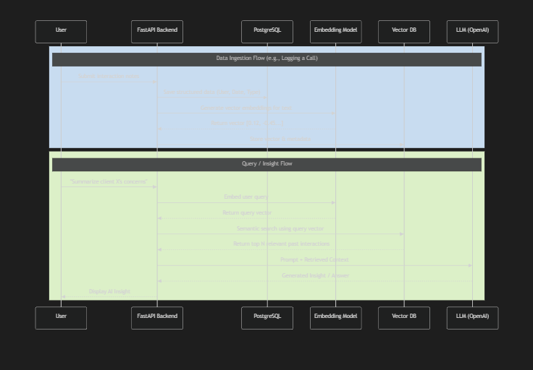
4. Key Features
- Semantic Search: Quickly retrieve past interactions, client notes, and context using natural language search queries instead of exact keyword matching.
- Client Interaction Tracking: Maintain a detailed, chronological timeline of all customer touchpoints (emails, calls, meetings).
- AI-Powered Insights: Automatically generate summaries and actionable insights from long or complex interaction histories.
- Sentiment Analysis: Analyze the tone of customer communications to gauge customer satisfaction and emotional state.
- Churn Prediction: Identify at-risk clients based on negative sentiment trends or decreasing interaction frequency, allowing for proactive retention strategies.

5. Technology Stack
Frontend
- Framework: Next.js (React)
- Language: TypeScript
- Styling: Tailwind CSS
Backend
- Framework: FastAPI (Python)
- Data Access: Object-Relational Mapping (ORM) using SQLAlchemy.
Databases & Storage
- Relational Database: PostgreSQL (for structured data like Users, Clients, and basic Interaction logs).
- Vector Database: Qdrant / Chroma (for storing text embeddings of interactions to enable semantic search and RAG).
AI & Machine Learning
- Models: OpenAI API or local deployment via Ollama.

6. CI/CD Pipeline & Deployment Strategy
The application leverages a seamless Continuous Integration and Continuous Deployment (CI/CD) pipeline for automated testing and release.
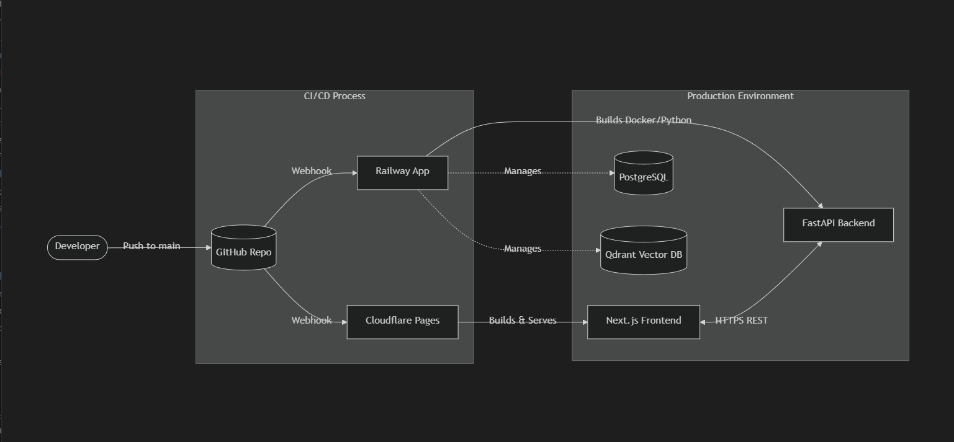
Pipeline Details:
- Version Control: Source code is hosted on GitHub.
- Frontend Deployment (Cloudflare Pages):
  - Triggered automatically on push to the main branch.
  - Cloudflare provisions a build environment, installs NPM dependencies, executes the Next.js build script, and deploys globally to their edge network for high availability and low latency.
- Backend Deployment (Railway):
  - Triggered via GitHub webhook.
  - Railway automatically detects the Python environment and railway.json configuration.
  - It builds the environment, installs requirements.txt, and securely connects the backend to Railway-managed managed database instances (PostgreSQL and Qdrant).
- Environment Variables: Secrets like OPENAI_API_KEY are securely injected into the respective deployment environments.

7. Project Images:
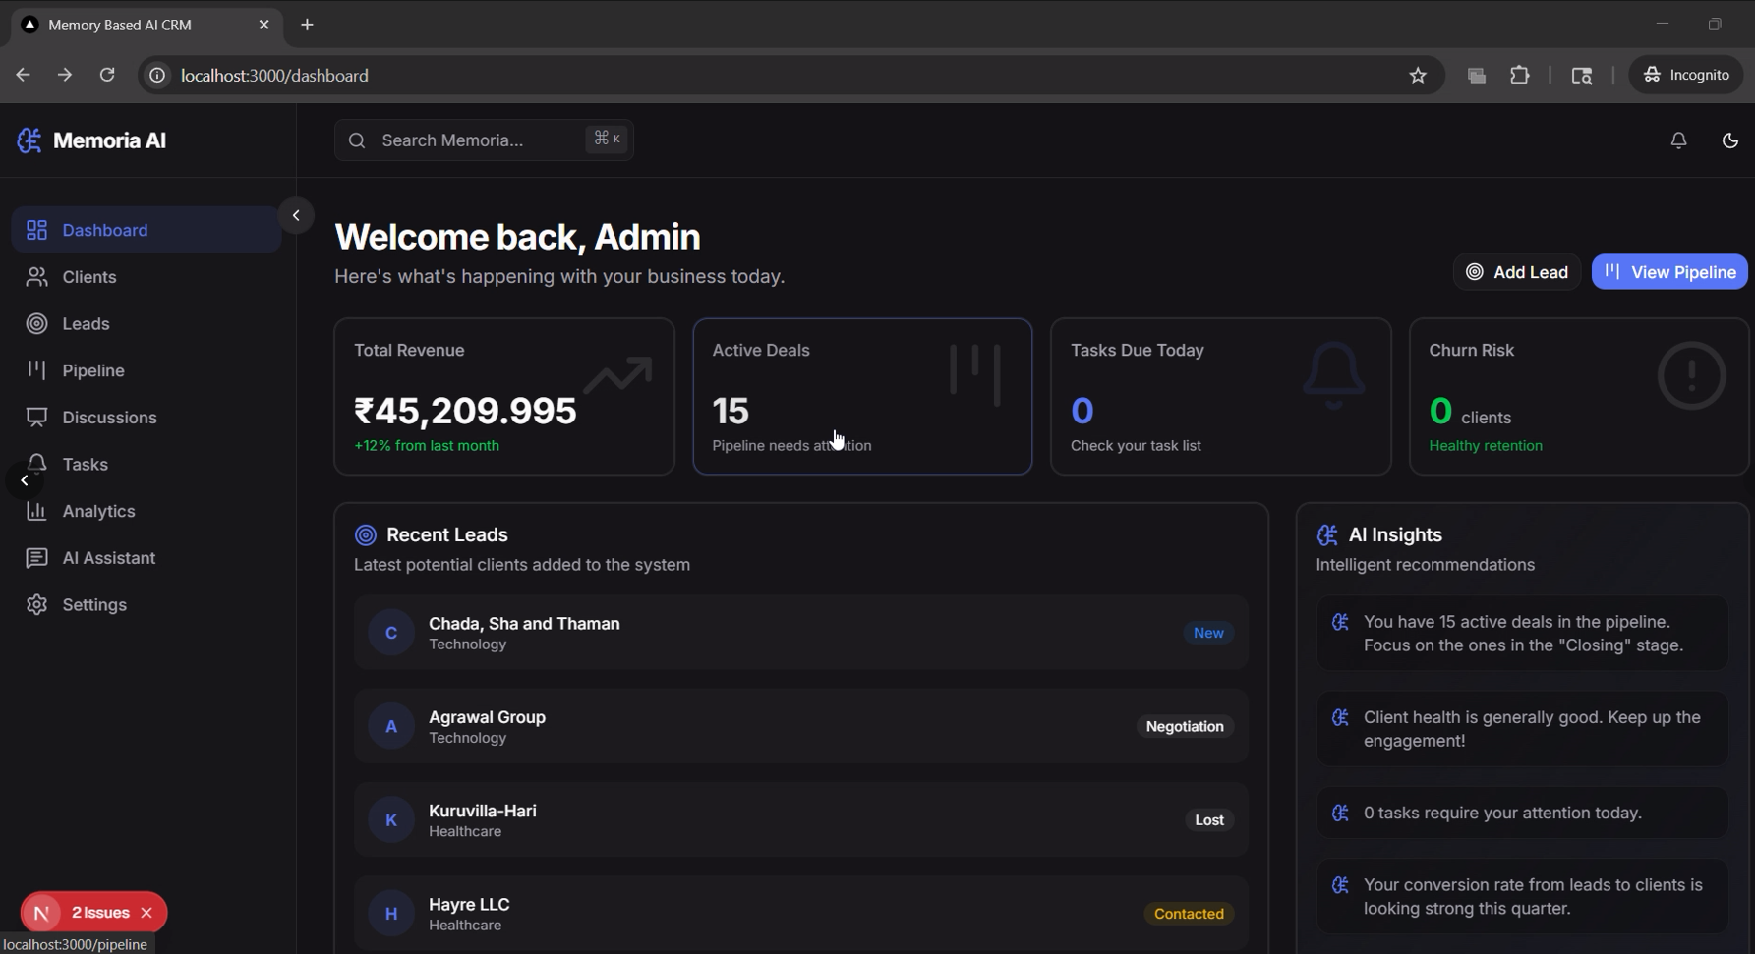
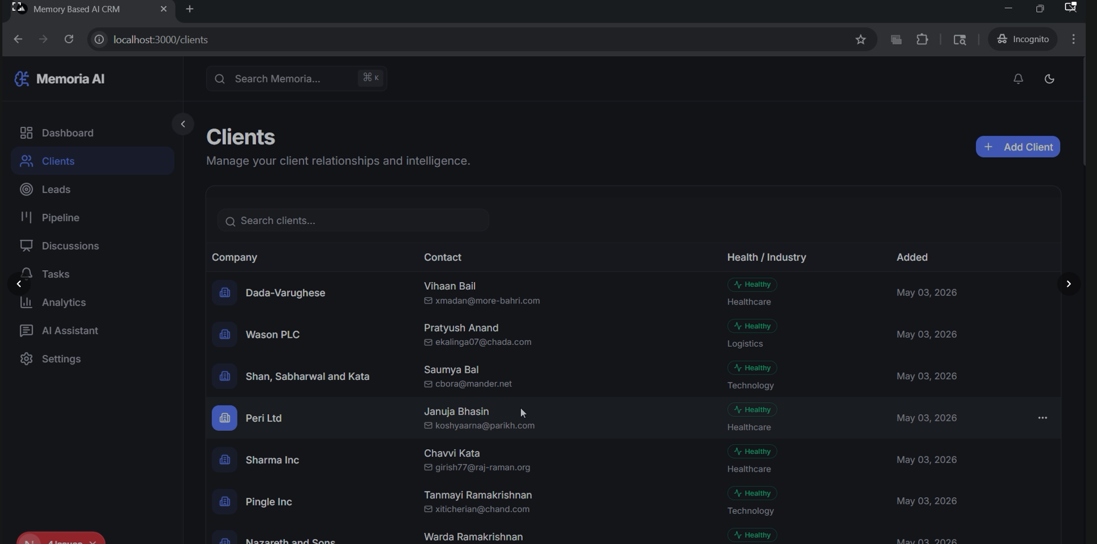
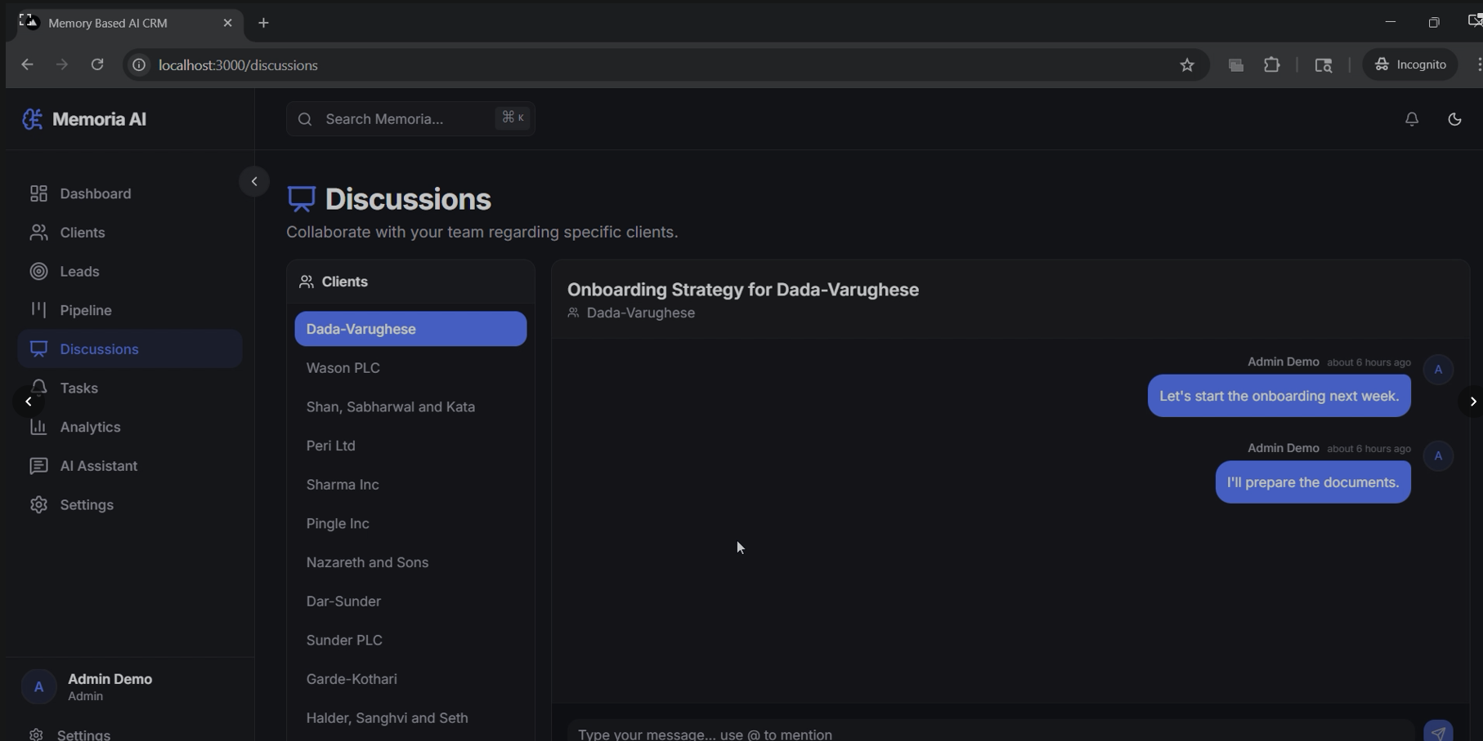
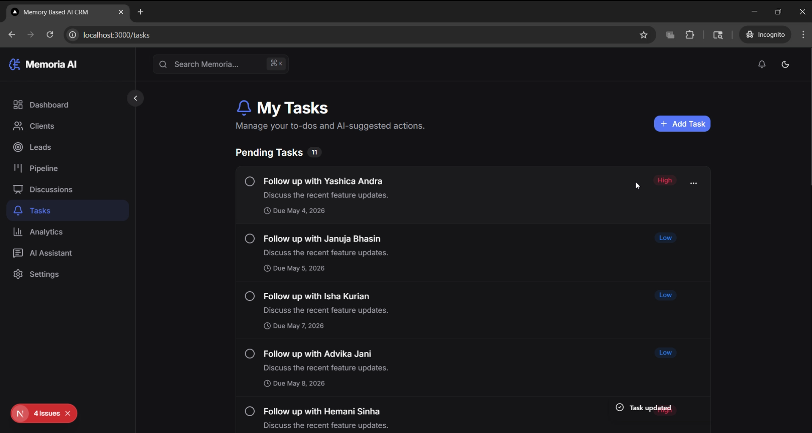
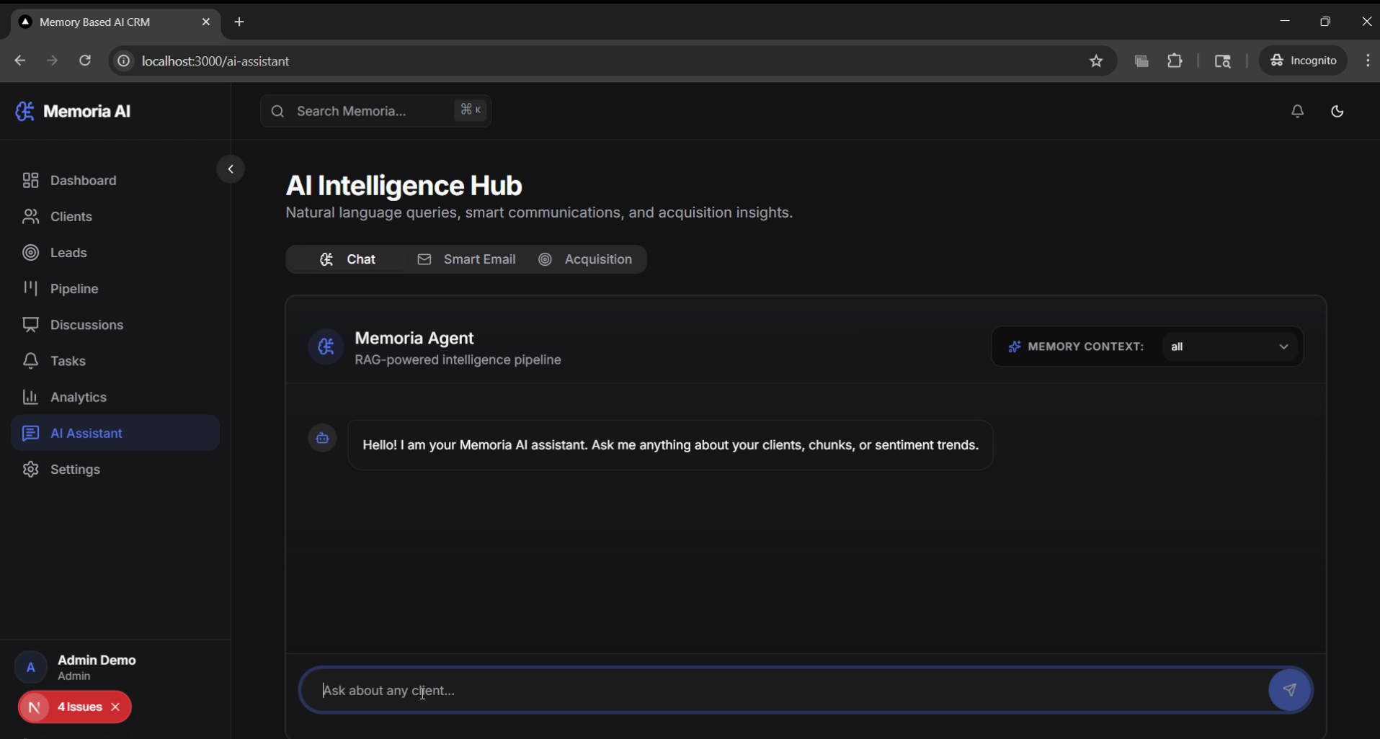

8. Future Enhancements
- Automated Ingestion: Integrate directly with email providers (Gmail, Outlook) to automatically log interactions.
- Advanced Analytics Dashboard: Visualizing overall company sentiment and churn risk distribution.
- Multi-Tenant Architecture: Scaling the database and vector storage to support multiple distinct organizations within the same instance.

